## Analysis Methodology

It is simply an organized, conceptual and a well-managed process for the analysis of requirements. There are numerous procedures some are Soft approach analysis methodology, Hard approach analysis methodology and Combined approach analysis methodology. Here combined approach is a fusion of Hard approach and Soft approach.

Here for this system I have used a Hard approach because it focuses mainly on the technical aspects. This approach is also for large complex systems but it can also be used in smaller systems. This approach uses SSADM (Structured System Analysis and Design Methodology). There are three views of a system according to SSADM:

**The Process View** which outlines all the functions that are carried out by the system and it also shows how the inputted data is moving around the system and how it is actually being processed.

**The Data View** outlines each and every data and information that the system uses.

**The Event View** outlines all the events that sets the process running in a system and also the effect of outer events on the data of the system.

There are several advantages of SSADM they are:

* Each step needs to be completed before progressing on towards the next one.
* It assures thorough planning of the system which can help in making of a better system.

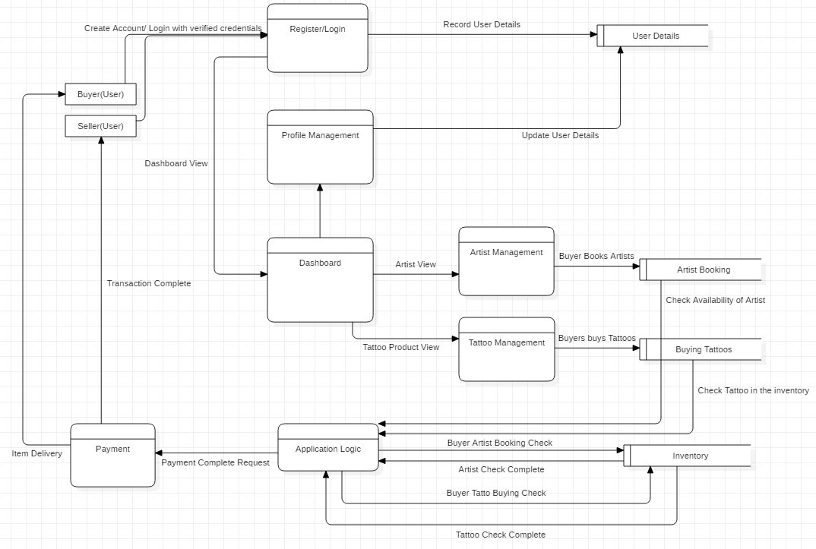

Figure 1 Data Flow Diagram